EFFECTS OF MEADOW EROSION AND RESTORATION ON GROUNDWATER STORAGE AND BASEFLOW IN NATIONAL FORESTS IN THE SIERRA NEVADA, CALIFORNIA
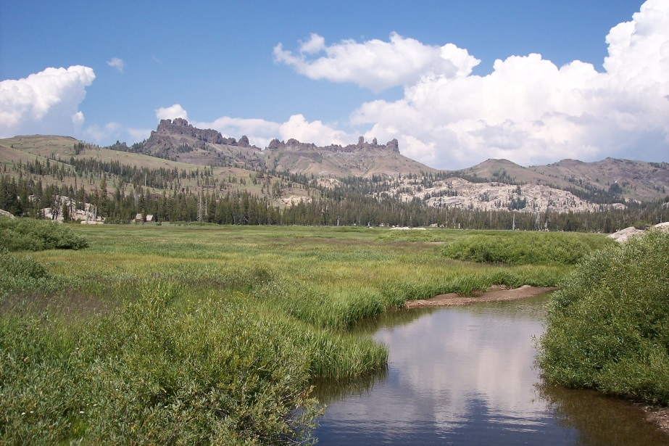
USDA Forest Service
Pacific Southwest Region
Vallejo, California
In cooperation with:
National Fish and Wildlife Foundation
California Department of Water Resources
June 19, 2015

Cover photo, Cooper Meadow, Stanislaus National Forest, USFS photo by Jim Frazier
CONTRIBUTORS
Carolyn Hunsaker, PhD, USDA Forest Service, Pacific Southwest Research Station
Sherman Swanson, PhD, University of Nevada Reno
Adam McMahon, MS, University of Nevada, Reno
Joshua Viers, PhD, University of California Davis (now at the Merced campus)
Barry Hill, MS, USDA Forest Service, Pacific Southwest Region
EXECUTIVE SUMMARY
Meadows in the Sierra Nevada maintain summer groundwater levels at or near the land surface in an otherwise seasonally dry montane landscape. Their role in retaining and releasing water makes meadows critically important for the hydrology of California’s headwaters as well as for fish and wildlife habitat, cultural resources, forage production, wildfire fuel loading, and recreation.
Many of the meadows in the Sierra Nevada have been eroded by incised channels, also known as entrenched channels or gullies. Channel incision increases local groundwater flow gradients and, consequently, groundwater discharge from meadow aquifers to streams. This enhanced groundwater drainage results in lower water-table elevations, decreased groundwater retention, and conversion of wet meadows to forested or brush-covered alluvial flats.
Total meadow area within the 10 Sierra Nevada National Forests, including eroded meadows that have lost their wet-meadow vegetation, is roughly 89,500 ha. More than half of these meadows are eroded by incised channels. Erosion generally has not reached great depths, and relatively inexpensive measures to protect and restore meadows, such as log check dams, relocation of roads and trails, and riparian fencing, are likely to be successful if implemented. Erosion continues at present to extend and deepen channels through meadows, particularly during floods, so timely implementation of meadow restoration measures will be important for protecting meadow resources and ecosystem services, including groundwater storage, carbon sequestration, and wildlife habitat.
Historical evidence indicates that prior to approximately 1930, most Sierra Nevada meadows were not incised and had perennial surface flows. Meadow erosion probably started in the late 1800’s and continues to the present, but most of the erosion apparently occurred between 1930 and 1960. The limited available streamflow records for large watersheds that include substantial areas of meadow do not indicate any major secular changes in streamflow that can be attributed to meadow erosion. However, streamflow records for locations downstream of eroded meadows show less consistency in relation to precipitation than do records for the Merced River, downstream of large but unincised meadows.
Overbank flood recharge is a key process in maintaining meadow groundwater and streamflow. In meadows where overbank flood recharge is an important source of groundwater, erosion can be expected to deplete groundwater storage and decrease baseflows, whereas restoration can be expected to improve groundwater storage and baseflows. About half of the meadows surveyed for this report have through-flowing streams and are likely to experience overbank flows in most years unless erosion precludes such flows. In meadows that are supplied primarily by persistent regional groundwater flow rather than overbank recharge, erosion is likely to increase baseflows, at least temporarily, while depleting regional groundwater storage. In meadows that are located in watersheds that are too small or too dry to have either through-flowing streams or large volumes of regional groundwater flow, erosion and restoration are unlikely to greatly affect groundwater or streamflow.
Summer groundwater balances show that restored meadows, considered at the regional scale, are not substantially different from eroded or partially eroded meadows in terms of groundwater storage or discharge to streams per unit of meadow area. Apparently other factors such as climate and geology are more important controls on meadow groundwater processes than is erosion status. However, restored meadows that have through-flowing streams maintain groundwater storage and baseflows during successive drought years, whereas eroded meadows have substantial decreases in storage and flows in sequential dry years. The maintenance of baseflows in some restored meadows may be a result of hydraulic redistribution of groundwater by meadow vegetation.
Although several studies have shown that meadow evapotranspiration is higher after restoration, our summer groundwater balances do not show a clear distinction between eroded, partially eroded, and restored meadows in terms of groundwater evapotranspiration rates at the regional scale. Meadow groundwater evapotranspiration in almost all meadows is supplied primarily by inflowing groundwater from bedrock aquifers rather than by depletion of groundwater stored in meadow aquifers. Loss of groundwater to evapotranspiration was substantially less than discharge of groundwater to streams in all meadows studied.
Restoration of all eroded meadows on National Forests in the Sierra Nevada could provide an additional 42,800,000 m³ (35,000 acre-feet) of annual groundwater storage, equivalent to roughly 2% of the average annual water delivery from the State Water Project. This total does not include surface waters stored by meadows during overbank floods.
Ponds excavated as borrow pits in restored meadows generally recharge groundwater and have evaporation rates comparable to those of healthy wet meadows. When refilled by overbank floods, these ponds are effective in recharging meadow aquifers and maintaining summer baseflows.
INTRODUCTION
Meadows in the Sierra Nevada maintain summer groundwater levels at or near the land surface in an otherwise seasonally dry montane landscape. Their role in retaining and releasing water makes meadows critically important for the hydrology of California’s headwaters as well as for fish and wildlife habitat, cultural resources, forage production, reduction of wildfire fuel loading, and recreation.
Many of the meadows in the Sierra Nevada have been eroded by incised channels, also known as entrenched channels or gullies. Channel incision initially increases local groundwater flow gradients and, consequently, groundwater discharge from meadow aquifers to streams. This enhanced groundwater drainage results in lower water-table elevations, decreased groundwater retention, and conversion of wet meadows to forested or brush-covered alluvial flats. The duration of the increased flow gradients and groundwater discharge rates can vary greatly, and depends in part on climatic conditions, as discussed below.
The USDA Forest Service, Pacific Southwest Region (USFS), has engaged in meadow restoration and protection using a variety of techniques over the past 80 years. The pace of restoration has increased recently owing to external partnerships and the advent of the “plug and pond” groundwater restoration technique. Future progress will depend on financial and political support for restoration, which in turn depends on scientifically credible demonstrations of benefits.
Changes in groundwater storage and streamflow regimen in response to meadow erosion and restoration will have important consequences for water resource management in California, and need to be understood in order to inform decisions on meadow protection and restoration. This report summarizes a 4-year study undertaken to evaluate the role of meadows in altering groundwater storage and baseflow regimen in Sierra Nevada headwaters on National Forest System lands.
Purpose and Scope
The USFS began a hydrological assessment of meadows on National Forest System (NFS) lands in 2010, with funding from the National Fish and Wildlife Foundation and the California Department of Water Resources. Study partners include the University of California Davis and Merced campuses, the U.S. Geological Survey National Research Program, and the University of Nevada Reno.
The purpose of this report is to evaluate the role of meadow erosion and restoration in storing and releasing groundwater on NFS lands in the 10 Sierra Nevada National Forests: Modoc, Lassen, Plumas, Tahoe, Lake Tahoe Basin, Eldorado, Stanislaus, Sierra, Sequoia, and Inyo. This report incorporates the efforts of the various study partners pursuing separate but related lines of evidence, including:
- Estimation of the aggregate regional meadow area and the extent and depth of erosion;
- Historical and anecdotal information regarding hydrologic conditions in meadows before and after erosion and restoration;
- Historical streamflow records that span periods of meadow erosion and restoration;
- A summary of previous studies of meadow hydrology in the Sierra Nevada;
- A groundwater model incorporating a meadow and various channel incision depths;
- An analysis of the hydrologic role of constructed ponds in restored meadows;
- Summer groundwater balances for selected representative meadows.
Some of the material included in this report has been previously published or released, including Fryoff-Hung and Viers (2013), McMahon (2013), and Essaid and Hill (2014).
Acknowledgements
The authors wish to acknowledge the support of Mike Chrisman, Timothy Male, Carly Vynne, and Claire Thorp of the National Fish and Wildlife Foundation (NFWF) and Kamyar Guivetchi, Ted Frank, Stefan Lorenzato, and Harry Spanglet of the California Department of Water Resources (DWR). In particular, we wish to acknowledge the guidance of the late Jim Sedell of NFWF and USFS, retired, whose leadership and vision were instrumental in focusing the attention of conservationists on Sierra Nevada meadows. We also appreciate the assistance with field and laboratory work provided by Kevin Cornwell, California State University Sacramento, Todd Hillaire, Department of Water Resources, Bob Rice and Martha Conklin, University of California Merced, and Lorrie Flint and Michelle Stern of the U.S. Geological Survey, California Water Science Center, Sacramento, as well as the numerous employees of the USDA Forest Service that assisted with various aspects of the project.
Meadows in the Sierra Nevada landscape
Meadows, as considered in this assessment, conform to the description of Wood (1975), and consist of low-gradient valley-bottom landforms with high water tables in fine-grained alluvial and organic strata. Ecologically, meadows have been defined by Weixelman and others (2011) as ecosystems composed of plant communities dominated by herbaceous species that rely on surface water or shallow groundwater. Meadows evaluated in this assessment are generally of the normal and lotic hydrologic classes of Ratliff (1985) and the riparian and subsurface types of Weixelman and others (2011).
Meadows occur on NFS land from roughly 1,220 m above MSL on both the west and east sides of the Sierra Nevada crest to elevations of nearly 3,660 m above MSL in the southern Sierra Nevada. In terms of elevation, meadows have been classified as montane (mid-altitude, up to roughly 2,130 m above MSL), subalpine (approximately 2,130 to 2,740 m above MSL), and alpine (high altitudinal, more than 2,740 m above MSL; Sharsmith, 1959).
Meadows are found on all major rock units of the Sierra Nevada. These include granite and granodiorite, extrusive igneous rocks such as andesite, basalt, and pyroclastic deposits, metamorphic rocks, and sedimentary units, including glacial till and lacustrine deposits. Meadows occur in both glaciated and non-glaciated watersheds (Wood, 1975).
Meadows form on alluvium that is deposited owing to low stream gradients that decrease stream power. Low stream gradients in the Sierra Nevada generally result from flow obstructions such as structural depressions, faults, volcanos, alluvial fans, landslides, glacial deposits, vegetative growth, woody debris accumulation (Koehler and Anderson, 1994), and possibly beaver activity in some areas (Lanman and others, 2012). Many of the larger meadows in the northern Sierra Nevada developed on Pleistocene lake beds (Burnett and Jennings, 1962), but most meadows in the range developed from floodplain and alluvial fan deposition rather than from infilling of lake basins (Wood, 1975). Meadows range in size from fractions of a hectare to tens of square kilometers. The largest meadows occur in structural depressions in the northern Sierra Nevada and on the Kern Plateau in the southern Sierra Nevada, where volcanism impounded stream valleys. Meadows in the central Sierra Nevada are relatively small features. Narrow riparian meadows are sometimes called “stringers.”
Stratigraphic studies of meadows in the Sierra Nevada indicate that alluvium underlying meadows was predominantly deposited in the late Pleistocene and the Holocene (Wood, 1975; Anderson and others, 1994; Koehler and Anderson, 1994). Alluvial valley floors have alternated between forest and meadow vegetation during the Holocene, with forests occupying valley floors during dry periods and meadows during wet periods (Wood, 1975). The alluvial deposits themselves, however, have apparently been stable or depositional features throughout most of the Holocene, with no evidence for cut-and-fill cycles (Wood, 1975; Benedict, 1982). Meadow alluvium is generally within the silt and sand size ranges (0.004 to 2 mm), but often includes gravel layers, particularly in deposits dating to the Pleistocene-Holocene transition (Wood, 1975). Many but not all meadows have developed thick layers of peat during wetter periods within the Holocene (Wood, 1975; Anderson and Smith, 1994; Koehler and Anderson, 1994). In general, meadow stratigraphy can be characterized as stratified and highly heterogeneous, with hydraulic properties that vary substantially with depth.
Vegetation on unincised wet meadows consists of saturation-tolerant herbaceous species such as sedges, rushes, and some grasses and forbs. Sedges and rushes in particular tend to form a dense, erosion-resistant sod owing to high root densities in the upper meter of meadow alluvium. Woody phreatophytes such as willow, alder, cottonwood, and aspen are also common.
Conifer or sagebrush invasion of meadows frequently follows declines in meadow water tables (Bradley, 1912; Bartolome and others, 1990; Millar and others, 2004; Darrouzet-Nardi and others, 2006), which is often but not always a result of channel incision. These upland woody species offer less resistance to fluvial erosion than do the wet-meadow sod-forming sedges and rushes, and meadow erosion can accelerate as a result of meadow invasion by xeric vegetation (Micheli and Kirchner, 2002).
EXTENT OF MEADOW EROSION
The first step in determining the extent of meadow erosion on NFS lands in the Sierra Nevada is to determine the aggregate area of meadows. Previous inventories of meadows on NFS lands in the Sierra Nevada include the Sierra Nevada Framework Planning Amendment inventory (2001) and the National Wetlands Inventory managed by the U.S. Fish and Wildlife Service. Both of these inventories show totals of approximately 89,000 ha of meadows on NFS lands, but the totals for individual National Forests do not match as well, indicating some discrepancies in delineation of meadows.
A remotely-sensed meadow delineation was completed in summer 2010 by staff of the USDA Forest Service Remote Sensing Laboratory in Sacramento, California. This delineation was based on the following criteria:
- Contiguous polygons of 2 ha or more with topographic slopes of 6% or less, and
- Within 50 m of any National Hydrographic Dataset stream channel, and
- Including any pixels of herbaceous or shrub vegetation as determined on the USFS vegetation type coverage.

This delineation, on inspection, gave reasonable results for meadows in the northern and central Sierra Nevada, but was overly inclusive in the drier areas of the southern Sierra Nevada. Comparison of delineated “meadow” polygons on portions of the Inyo National Forest with satellite imagery, for example, indicated that some delineated polygons were clearly upland sites that happened to be relatively flat. The final polygon layer consisted of 26,085 features spanning a total area of 249,200 ha.
The UC Davis Watershed Studies Unit completed field surveys of 111 of the remotely delineated meadows on the 10 Sierra Nevada National Forests and 3 in Yosemite National Park (Figure 1). These meadows were randomly selected from meadows with long-term ecological monitoring sites evaluated on a 5-year rotation by the USFS (Weixelman, 2011).

Meadows were delineated by walking the perimeter of each meadow with a differentially corrected GPS unit. Meadows were considered to be all valley-bottom alluvial landforms with topographic slopes less than 6% and underlain by fine-grained alluvial and organic strata. Based on a comparison of the remote and field meadow delineations, the remotely delineated meadows overestimate meadow areas by a factor of roughly 3. The final UCD project report (Fryoff-Hung and Viers, 2013), including documentation of methods and results for each of the 111 meadows surveyed, can be found at:

http://hydra.ucdavis.edu/files/hydra/SNMP_StatusReport_2012_Final.pdf
Owing to the discrepancy between the remotely delineated and field delineated meadow areas, the UC Davis team developed an alternative inventory of meadows in the Sierra Nevada based on existing surveys at the National Forests and by other agencies, including the National Park Service and the California Department of Fish and Wildlife. The total number of meadows on National Forest System (NFS) lands in Region 5 as determined from this inventory is 8,190, with an aggregate area of 35,000 ha.

Based on a visual comparison of the UCD meadow inventory with satellite imagery of meadows, we determined that the UCD layer, while accurate for meadows that retained wet meadow vegetation, did not generally include meadows encroached by woody vegetation. We therefore decided to use the aggregate meadow area of 89,000 ha from the Sierra Nevada Framework Planning Amendment (Table 1).

The next step in determining the extent of meadow erosion was to evaluate a representative subsample of meadows, determine what proportion of these are eroded, and to determine depths of erosion (vertical distances between the meadow surface and the channel bed) for eroded meadows. The UCD field crew made the erosion assessment using the same meadows used for field delineations. Meadows were classified as eroded if the following conditions were observed:

- Near-vertical unvegetated channel banks with heights of 0.6 m or more over 25% or more of total channel length through the meadow;
- Knickpoints or headcuts greater than 0.6 m in height;
- Bank heights decreasing downstream;
- Channel bed elevations more than 0.3 m below the rooting depths of riparian plants;
- No evidence of recent overbank flows on the meadow surface.
Average gully depths were measured at 10 locations at approximately equal intervals along the channel thalwegs of eroded meadows. Gully depths were measured as the vertical distances between thalweg and meadow surface elevations along gully banks using hand levels and surveying rods. Average depths included observations of zero depth for locations on eroded meadows that are not incised by gullies. However, no channel depth measurements were made on meadows classified as non-eroded.
The results shown in Table 2 indicate that over 70% of all meadows on NFS lands in the Sierra Nevada are eroded by incised channels, with an average erosion depth of 0.6 m and an average maximum erosion depth of 1.3 m. Greater erosion depths were associated with larger meadow areas (Table 2).
Recorded observations and photographs included in the UC Davis final report provide insight into meadow conditions and dynamics. This information is useful in assessing the hydrologic role of meadows and recent trends in hydrologic conditions. Of the meadows surveyed:
- 58% included fens, springs, or ponds, and over half of these meadows were eroded by gullies;
- 63% had encroachment by shrubs or conifers, and of these, 84% were eroded by gullies;
- 14% had dieback of woody species, and these meadows were almost 3 times more likely to be eroded than not.

The high proportion of meadows with fens, springs, or ponds indicates that most meadows have perennially high water tables in at least some locations, even when eroded. The high proportion of meadows with shrub and conifer encroachment, and the low proportion with dieback of woody species, indicates that meadows have become drier over recent decades, possibly as a result of gully erosion and groundwater drainage.
In addition:
- 46% of meadows had through-flowing streams, with both surface-water inflows and outflows;
- 4% had surface-water inflows, but no outflows;
- 27% had surface-water outflows, but no inflows;
- 22% had no surface water.

Almost 75% of all meadows surveyed had surface water outflows at the time of the surveys. About a quarter of all surveyed meadows acted as headwater sources of streamflow. Only a small percentage functioned as sinks for influent surface flows.

HISTORICAL ANECDOTAL INFORMATION ON MEADOW EROSION STATUS AND HYDROLOGY
Historical accounts, although not quantitative, provide some indications of meadow conditions prior to and after erosion. These accounts also establish a general timeframe for channel incision in meadows, which is important for interpreting the available streamflow records for gages downstream of eroded meadows. Most of the useful historical information is for meadows in the Feather River watershed (Plumas National Forest) in the northern Sierra Nevada and for meadows on the Kern Plateau in the watershed of the South Fork Kern River (Inyo National Forest) in the southern Sierra Nevada. These meadow systems are large and topographically connected, with extensive and deep channel incision.
Northern Sierra Nevada
The Feather River watershed was visited by a number of scientists and technical experts in the late nineteenth and early twentieth centuries. These technical experts were charged with evaluating the potential for the production of minerals, crops, and hydropower in Plumas County. Their observations included the status of irrigated lands, streamflow, and mineral deposits. Although not focused on meadow erosion or hydrology, their reports provide information useful for inferring meadow hydrologic conditions during this period.
Meadows in the upper Feather River watershed in the late nineteenth and early twentieth centuries were generally well-watered and supported perennial streamflow. These meadows were described in 1892 as “grassy and well watered but treeless (California State Board of Horticulture, 1892, p. 379).” Clapp (1907) described Plumas meadows as having well-regulated flows and large perennial springs along their margins. Diller (1908) described some meadows in the Indian Valley area as “swampy” but noted others as being dry. Clapp and Henshaw (1911) stated that “the numerous meadows and valleys that exist in different parts of the area (Feather River basin) also help maintain a steady flow during the dry season (p. 132).” Adams and others (1912) reported that meadows in Indian Valley were naturally irrigated by seasonal high flows. Meadow soils were described as “permanently relatively moist (p. 41)” and in need of drainage (p. 40). MacBoyle (1918) evaluated alluvial materials for mineral production in Plumas County, and did not mention any observations of channel incision in meadows.
By the 1930s, meadow conditions were substantially altered from those observed 20 to 30 years previously. Hughes (1934) described deeply eroded meadows along Last Chance Creek and noted that streams there carried little or no water during summer. He compared pre-erosion to post-erosion conditions for the Last Chance meadows:
“Originally the meadows were well watered by meandering streams whose courses were often concealed by rank vegetation. The through frequent deep pools covered by lily pads, and in the spring the water stood over practically the entire area of many of the meadows, while the water table was high, even in summer, because the drainage channels were shallow. The abundance of water produced and excellent crop of forage or hay, and the country was prosperous. Most of the meadow land was patented in the early days.
“At present no such meadows exist in the Last Chance area and instead of meandering streams with well vegetated courses bare gullies with caving banks cut straight across practically every meadow. The result is that instead of water being distributed to the soil from meanders and pools throughout the summer, it runs off rapidly when the snow melts and leaves the meadows with water tables as much as 15 feet (5 m) lower than they formerly were.”
Reports by Cotton (1908) and Hughes (1934) noted that meadow erosion may have begun as early as 1900. An investigation by the USDA Soil Conservation Service (now Natural Resources Conservation Service; 1989) reported that major channel erosion occurred between 1850 and 1940, with accelerated downcutting between 1900 and 1940, but little downcutting after 1940 (p. 10-13). Apparently a substantial number of meadows on the Modoc and Lassen National Forests to the north of the Feather River watershed had been eroded by the early 1940s (Hormay, 1943).
In summary, meadows in the upper Feather River watershed were eroded primarily between 1900 and 1940, although some erosion likely occurred both earlier and later. Prior to erosion, meadows were well-watered and supported perennial streamflow. Following erosion, meadows no longer retained groundwater throughout the summer, and streamflow in at least some locations became intermittent.
Southern Sierra Nevada
The southern Sierra Nevada meadows most frequently observed and described by scientists and conservationists in the late nineteenth and early twentieth centuries were those in Yosemite National Park and on the Kern Plateau in the Inyo National Forest.
Accounts by King (1871) and Muir (1895) describe damage to meadow vegetation by grazing livestock in both Yosemite and the Kern Plateau, but do not report observations of channel incision in meadows. Muir (1895) in fact refers to meadow sod as being intact after heavy grazing by sheep. Dyer (1893) describes his trip through the Kern Plateau meadows, and similarly does not report any observations of meadow erosion. Photographs taken by G.K. Gilbert of the U.S. Geological Survey in Big Whitney Meadow in 1903 show a shallow unincised channel along Golden Trout Creek, which is presently incised (Fig. 2). Knopf (1918) describes Mulkey Meadow, presently deeply and extensively eroded, as a “broad grassy meadow,” although he mentions incipient channel incision in a nearby meadow along Carthage Creek. Bradley (1912) described meadows in Yosemite National Park as “sponges” that absorb snowmelt and slowly release surface water during the summer: “A brooklet rising in a chain of such little meadows is almost sure to preserve its flow throughout the season (p. 41).”
Most meadows within Yosemite National Park remain in good condition, without deeply incised channels (Ballenger and others, 2012). However, a few meadows have been eroded as a result of ditching and other land uses.
In contrast, many of the large meadows on the Kern Plateau are now deeply incised (Micheli and Kirchner, 2002). A photograph from the Wieslander collection (www.lib.berkeley/BIOS/vtm) taken at Big Pine Meadow in 1931 shows advanced gully erosion that likely began years before the date of the photograph (Fig. 3). A major episode of channel incision through Monache Meadow on the Kern Plateau was observed as recently as the 1980s (Sims, Lisa, Inyo National Forest, personal commun.) and headcuts continue to erode upstream through meadows on the Plateau (Shannon, Casey, Inyo National Forest, written commun., 2014; Fig 4).
Meadows on the Sierra and Sequoia National Forests, as well as the Sequoia-Kings Canyon National Park, were incised between 1911 and 1966 (Wood, 1975). Crane (1950) found that 5% of the wet meadows on the present Humboldt-Toiyabe National Forest on the east side of the Sierra Nevada were eroded by gullies in the late 1940s. An additional 16% were reported to have “scoured drainage channels…but no gullies (p. 307).” Contemporary headcut progression has been recently documented on the Sequoia National Forest (Courter, Joshua, Sequoia National Forest, written commun., 2013).
In summary, erosion of southern Sierra Nevada meadows became widespread after 1910, and possibly as late as the 1940s. Meadow erosion continued through the late twentieth century, and in at least some meadows, headcuts are continuing to progress upstream at present.
HISTORICAL STREAMFLOW RECORDS
Systematic streamflow measurements in the Sierra Nevada began in the early 1900s. Based on the available historical information, many Sierra Nevada meadows were eroded during periods with available streamflow records for downstream gaging stations. Any significant secular trends in streamflow resulting from meadow erosion might therefore be detectable in historical streamflow records.
Unfortunately, long-term streamflow records for watersheds with large areas of eroded meadows are rare. Those records that do exist are usually for locations so far downstream as to make the effects of headwater meadow erosion very difficult to detect, considering the other changes in land use and forest cover that may have affected streamflow during the past 100 years.
However, some inferences regarding meadow erosion effects on streamflow can be made using double-mass curves (Searcy and Hardison, 1960). Double-mass curves are plots of cumulative annual precipitation (horizontal axis) vs. cumulative annual average streamflow (vertical axis). If relations between precipitation and streamflow remain constant, the curves plot as straight lines. Deviations from straight lines indicate changes in relations between rainfall and streamflow, as might result from wildfires, logging, road construction, increases in forest stand density, and meadow erosion. A bend toward the right indicates a decreasing streamflow trend, relative to precipitation, while a bend toward the left indicates an increasing trend. Although double-mass curves indicate hydrologic changes, they provide no information on the causes of the changes.
Double-mass curves for two U.S. Geological Survey streamflow gages from the southern Sierra Nevada are shown in figures 4 and 5. The two gages are on the Merced River in Yosemite National Park in Merced County and on the South Fork of the Kern River in Kern County, downstream of the Inyo and Sequoia National Forests. Rainfall data from DWR stations within the watersheds upstream of the streamflow gages were used for the graphs. The Merced River watershed has numerous meadows in generally good condition, without extensive channel incision (Ballenger and others, 2012). The South Fork of the Kern River has substantial areas of deeply eroded meadows within its watershed. The timing of the erosion is not well established, but most of the erosion likely occurred between 1920 and 1950, based on photographic evidence and historical accounts.
The curve for the Merced River (fig. 5) is straighter than the curve for the South Fork of the Kern River (fig. 6). The double-mass curve for the South Fork Kern River shows an upward bend starting in 1934, indicating a relative increase in streamflow, and a downward trend starting in 1950, indicating a relative decrease in streamflow. Later shifts in the double-mass curve for the South Fork Kern River are also apparent (fig. 6).
As the Merced River drains a watershed entirely within Yosemite National Park, and the South Fork of the Kern River drain watersheds mostly within National Forests, the differences in the curves may be attributable to differences in land management. The fluctuations in the double-mass curve for the South Fork Kern River (fig. 6) coincide with the likely period of channel incision on the Kern Plateau, and meadow erosion therefore may have been a factor in the changing relations between precipitation and streamflow apparent in figure 6.
A double-mass curve for Indian Creek, a major tributary of the East Branch North Fork Feather River, is shown in figure 7 for water years between 1907, when streamflow measurements began, and 1956, when streamflow became affected by construction of a dam upstream. Records are not available for water years 1910-11 and 1918-1930. The curve indicates that a shift toward lower streamflow had begun when streamflow records resumed in 1931. This trend was most evident between 1931 and1934, coinciding with a period of low rainfall. However, a similar period of low rainfall between 1912 and 1916 did not result in a similar shift in the relationship between cumulative streamflow and cumulative precipitation. Even after the 1931-34 drought, streamflow relative to precipitation was lower than it was between 1907 and 1917 (Fig. 7).
Indian Creek and its tributaries, including Last Chance and Red Clover Creeks, flow through many kilometers of meadows that were deeply eroded by the time that meadow restoration efforts began in the late 1980s (USDA Soils Conservation Service, 1989). The changes in precipitation-streamflow relations shown in figure 6 occurred during the period when channel incision was actively progressing through the watershed. Meadow erosion may therefore have been a factor affecting precipitation-streamflow relations on Indian Creek.
In summary, the limited available historical streamflow records indicate that changes in streamflow relative to precipitation coincided with periods of meadow erosion in watersheds that experienced extensive meadow erosion in the twentieth century. Short-term upward and downward trends in streamflow relative to precipitation are apparent during periods of meadow erosion in the South Fork Kern and Indian Creek watersheds. Relations between streamflow and precipitation in the Merced River watershed, which has large areas of uneroded meadows, do not show similar changes. No long-term secular trends, upward or downward, were apparent for any of these watersheds, possibly because the areas of the watersheds with long-term streamflow records are too large to discern changes resulting from meadow erosion.
PREVIOUS STUDIES OF MEADOW HYDROLOGY
Meadows are seasonal or perennial groundwater discharge zones connected to regional groundwater flow systems (Loheide and others, 2009). In this section, we review previous studies of Sierra Nevada meadow hydrology to determine the role of meadows in affecting evapotranspiration, groundwater retention, and streamflow.
Meadow evapotranspiration
Wet meadows generally transpire slightly more water per unit area than surrounding conifer forests during dry summers (Loheide and Gorelick, 2007). However, in the montane elevational zone, evapotranspiration by conifers continues at reduced rates during fall, winter, and spring (Goulden and others, 2012), whereas evapotranspiration from meadows ceases when meadow vegetation undergoes senescence at the end of summer (Wood, 1975). On an annual basis, evapotranspiration per unit area may be as high or higher in forests than in meadows at montane elevations in the Sierra Nevada.
Erosion generally reduces meadow evapotranspiration (ET) by draining water from the meadow rooting zone, whereas restoration increases ET (Loheide and Gorelick, 2007). ET includes water removed from the saturated zone and water removed from unsaturated storage (Lowry and Loheide, 2010). For our purposes, we are concerned with ET from the saturated zone (groundwater ET).
Wet-meadow ET has been reported to total about 6 mm per day, or 54 cm of water depth for a 90-day growing season (for example, Wood, 1975; Loheide and Gorelick, 2005). Lowry and Loheide (2010) reported that groundwater supplies about 3 mm per day for ET in wet meadows, equivalent to 27 cm for a 90-day growing season, with another 3 mm per day coming from unsaturated soil moisture storage. The wet-meadow ET rate of 6 mm/day is about twice that for vegetation that grows on eroded meadows, such as big sagebrush, conifers, and annual grasses (Loheide and Gorelick, 2007). Although wet meadow evapotranspiration has generally been considered negligible outside the normal growing season (Wood, 1975), evapotranspiration is likely to continue at reduced rates throughout much of the year in eroded montane meadows that support conifers and brush.
Meadow groundwater retention
Aquifers in uneroded meadows are generally fully recharged by rain and snowmelt during the winter and spring (Wood, 1975; Loheide and Gorelick, 2007; Hammersmark and others, 2008; Cornwell and Brown, 2008; Brown, 2013). Overbank flooding is an important contributor to recharge in some meadows (Hammersmark and others, 2008; Tague and others, 2008; Ohara and others, 2013), but meadows may also be saturated by groundwater flowing from surrounding bedrock aquifers (Essaid and Hill, 2014). Meadow saturation is maintained by inflowing streams and groundwater through mid-summer, when ET and drainage begin to deplete meadow aquifers (Wood, 1975; Loheide and Gorelick, 2007). Water tables in uneroded meadows generally fall to maximum depths of roughly one meter below meadow surfaces by August or September, and then begin to recover as evapotranspiration decreases and groundwater inflow continues (Wood, 1975).
Meadows eroded by deep gullies lose their ability to retain groundwater owing to increased local hydraulic gradients that temporarily increase groundwater discharge from meadow aquifers to eroded channels (for example, Loheide and Gorelick, 2007), particularly if meadow alluvium is highly permeable (Loheide and others, 2009). Meadow erosion usually reduces the loss of groundwater to ET as the water table falls below the rooting zone of meadow vegetation (Loheide and Gorelick, 2005). Meadow erosion can also affect recharge of meadow aquifers by reducing or eliminating overbank flooding, which reduces recharge (Hammersmark and others, 2008), and by providing additional storage capacity in winter and spring, which increases recharge (Essaid and Hill, 2014).
Previous studies of meadow hydrologic regimen (Table3) indicate that meadow incision only moderately increases the depths to which water table elevations fall in eroded meadows, relative to uneroded or restored meadows. However, incision does apparently limit the water table rise during recharge, preventing the water table from reaching the land surface and preventing recharge of meadow aquifers through overbank flooding.
Meadow groundwater discharge and streamflow
A total of five previous studies have demonstrated changes in streamflow following meadow restoration or erosion (Table 4). These studies have indicated a range of responses to changes in meadow geomorphic conditions.
Liang and others (2007) and Ohara and others (2013) used a watershed modeling approach to compare eroded and restored meadows in the headwaters of the East Branch North Fork Feather River, a relatively dry area with annual precipitation of 428 mm. Local bedrock is mostly volcanic but includes some granite. They reported a 10 to 20% increase in baseflows following restoration due primarily to overbank flooding and recharge in the restored meadows. Their model did not include groundwater flow upward from bedrock aquifers into meadow alluvium because a low-permeability lacustrine layer was considered to effectively prevent upward flow into the meadow. The model included subsurface flow from hillslopes into meadow aquifers.
Hammersmark and others (2008) used a groundwater model to evaluate the hydrologic effects of restoration on Bear Creek, a tributary to the Fall River in the southern Cascade Range with annual precipitation of 508 mm and local bedrock consisting of highly permeable basalt. They found that the duration of surface flows within the meadow decreased slightly after restoration, but also found that baseflow volume increased downstream of the restored reach owing to increased groundwater flow along the axis of the highly permeable meadow alluvium. Changes in baseflow volumes were not quantified. Overbank flood recharge was an important process after restoration but not prior to restoration.
Tague and others (2008) used streamflow records from the U.S. Geological Survey to compare streamflow before and after restoration along Trout Creek upstream from Lake Tahoe. Annual precipitation was reported to range from 500 to 1,000 mm. Local bedrock is primarily grandodiorite, and the meadow overlies glacial till. Tague and others reported streamflow increases as high as 40% following restoration during early summer, apparently owing to overbank recharge and reduced flood flows in winter and spring. Flows in late summer were not much affected by restoration.
Essaid and Hill (2014) developed a groundwater flow model to evaluate the hydrologic effects of hypothetical channel incision in the Sagehen watershed within the Little Truckee River basin on the east side of the Sierra Nevada crest. Annual precipitation in the Sagehen watershed averages about 850 mm. The GSFLOW finite-difference watershed model (Markstrom and others, 2008) was used to compare hydrologic processes for natural conditions and hypothetical incision scenarios. The 1981-1988 period was used for the model, to include representative wet (1982-83) and dry (1987) years.
The results illustrate the interdependence between watershed and meadow hydrology, bedrock and meadow aquifers, and surface and groundwater flow through the meadow. During the wet season, stream incision resulted in less overland flow and interflow and more meadow recharge causing, a net decrease in streamflow and increase in groundwater storage relative to natural meadow conditions. Overbank flooding was not an important contributor to recharge in the meadow because the meadow was saturated to its surface early in the winter by influent groundwater. During the dry season, incision resulted in less meadow evapotranspiration and more groundwater discharge to the stream causing a net increase in streamflow and a decrease in groundwater storage relative to natural meadow conditions.
In general, the model showed that the magnitude of change in summer streamflow and long-term change in watershed groundwater storage due to incision will depend on the combined effect of reduced evapotranspiration in the eroded meadow, induced groundwater recharge, replenishment of dry season groundwater storage in meadow and bedrock aquifers by precipitation during wet years, and groundwater storage depletion that is not replenished by precipitation during wet years.
Meadow restoration in other parts of the Western United States has improved downstream flow volumes, extent, and duration (Heede, 1979; Elmore and others, 1987; Swanson and others, 1987; Ponce, 1990; Klein and others, 2007). Overbank recharge and bank storage were reported to be important in increasing baseflow in restored meadow reaches.
The relative importance of overbank flooding (Fig. 8) as a source of meadow groundwater recharge appears to be a factor that influences the hydrologic effects of meadow erosion and restoration. All of the studies that reported increases in baseflows after restoration also reported that overbank flooding during winter and spring was an important process in recharging meadow aquifers (Liang and others, 2007; Hammersmark and others, 2008; Tague and others, 2008; Ohara and others, 2013). In contrast, the study that reported an increase in baseflow after channel incision in the Sagehen watershed (Essaid and Hill, 2014) indicated that overbank flooding was not a source of meadow groundwater recharge. Instead, the meadow aquifer was replenished by groundwater flowing from surrounding hillslope and bedrock aquifers throughout the year. The persistent inflow of groundwater to the Sagehen meadows provided a source for increased discharge of groundwater to the stream channel throughout the dry season, increasing baseflows relative to the pre-erosion baseflows. The occurrence of overbank flood recharge in a given meadow may therefore usefully indicate whether erosion or restoration will positively or negatively affect summer baseflows.
MEADOW GROUNDWATER BALANCES
Meadow groundwater balances are useful in assessing the effects of erosion and restoration on streamflow, groundwater evapotranspiration, and groundwater storage during summer baseflow periods. Meadows used in the groundwater-balance study were selected to represent eroded, partially eroded, and restored or unincised meadows throughout the Sierra Nevada on a variety of bedrock types (Table 5; Fig. 1). Meadows were classified as eroded if channel incision to a depth of 1.0 m or more extended through at least half of the meadow length. Meadows were classified as partially eroded if channel incision was observed within the meadow but did not reach depths of 1.0 m over 50% of the meadow length.
Hydrologic data used to develop summer (July 1 to September 30) meadow ground water balances were collected in 2012 and 2013. These were both exceptionally dry years that followed an unusually wet year in 2011. Records maintained by the DWR (California Data Exchange) indicate that total annual precipitation was roughly 65 to 90% of long-term averages in the Sierra Nevada during 2012 and 2013. May snowpack measurements ranged from 220% of long-term averages in 2011to 7% in 2013 (Table 6). Snowmelt is usually a major source of water in the Sierra Nevada, so the very low snowpacks in 2012 and 2013 indicate very limited water supply during those years. Groundwater balance results are therefore representative of two successive drought years, and may not represent meadow conditions during wetter years.
Meadow groundwater balances for this project were developed based on hydrologic field data provided by the University of California Merced, including data collected by the Department of Water Resources, Balance Hydrologics, the U.S. Geological Survey, and the USDA Forest Service, Lake Tahoe Basin Management Unit (Table 7). Monitoring equipment (Table 8) was installed in summers of 2011 and 2012.
Methods
Conceptually, groundwater balances can be expressed as:
∑(GW_{I} – GW_{O})= ∑(Q_{O} – Q_{I}) + ∑(ET – RF) - ∆S_{A} (1)
where:
GW_{I} is groundwater flowing into the meadow from surrounding bedrock aquifers;
GW_{O} is groundwater flowing out of the meadow into streams, downstream alluvial aquifers, or surrounding bedrock aquifers;
∑(GW_{I} - GWo) is the seasonal sum of the difference between inflowing and outflowing groundwater ;
∑(Q_{O} – Q_{I}) is total volume of water represented by the difference between surface-water inflows and outflows during the monitoring period, as determined by periodic streamflow measurements and stage records;
∑(ET – RF) is the total volume of water represented by the difference between evapotranspiration and rainfall during the monitoring period; and
∆S_{A} is the decrease in groundwater stored in meadow alluvium during the monitoring period (values will be negative for increases in storage)
Groundwater balances were determined by measuring inflows and outflows of surface water, precipitation, changes in groundwater levels, and the specific yields of meadow aquifers. By convention, flows into the meadow aquifers were considered positive and flows out of meadow aquifers into streams, plants, the atmosphere, or down-gradient aquifers were considered negative.
Groundwater monitoring networks consisting of individual wells and nests of one well and 2 piezometers were installed by hand augering to measure water table elevations and hydraulic heads. Wells and piezometers were constructed of 5 cm diameter PVC pipes. Wells were installed to bedrock, or as deep as possible using a hand auger. Piezometers were installed at various depths, with one piezometer in each group installed to bedrock, or as deep as possible (Table 8). Within nests, wells and piezometers were installed close to each other to allow determination of vertical hydraulic gradients. A combined total of 9 to 16 wells and piezometers were installed in most meadows (Table 8).
Submersible pressure transducers were installed in all wells and piezometers to measure hourly water-levels with the exception of meadows M14 and M20. Meadows M14 and M20 had only piezometers installed, and only one piezometer in each meadow was equipped with a transducer and data logger. Manual water-level measurements were made semiannually in each well and piezometer for quality assurance and calibration purposes. Hourly water-level records were reviewed, and used only if the records met quality-assurance criteria. Records meeting the following criteria were generally considered to be of acceptable quality:
- Groundwater levels obtained with electronic recorders were within 15 cm of semiannual manual measurements and were reasonable in comparison to well construction information;
- Two or more groundwater level records per meadow during each year of the study met criteria for data quality and completeness;
- No more than 10 consecutive days of record were missing during a single summer;
- Water-level unit-value records were free of unexplained sudden jumps or drops of 5 cm or more.
Surface-water flows (streamflow) were monitored with submersible pressure transducers and stage recorders installed at the upstream and downstream ends of each of the meadows (Table 8), to determine surface-water inflows and outflows (Q_{I} and Q_{O}). Discharge (streamflow) was periodically measured at the upstream and downstream stations throughout summer and fall, using tracer measurements (salt dilutions) and measurements of stream velocity, depth, and width. Rating curves were developed from concurrent stage and discharge data, and used to convert measured stages to streamflow. Daily values of streamflow for Cold Creek, a tributary to the Trout Creek meadow, were estimated from U.S. Geological Survey streamflow records at nearby gages on the basis of drainage area. Groundwater discharge to meadow streams was computed as ∑(Q_{O} – Q_{I}).
Samples were collected during spring and summer of 2014 and analyzed for specific yield at 0.1 and 0.3 bars of applied pressure using a pressure plate apparatus (Klute, 1986) at the U.S. Geological Survey laboratory in Sacramento, California. Results for applied pressures of 0.3 bar (SY_{0.3}) represent long-term seasonal changes in groundwater storage in meadow aquifers and were used in groundwater balances (Table 9). The specific yield results for 0.1 bar represent shorter-term drainage, and were not used in water balance calculations.
Precipitation was rare during the study period. Hourly and daily rainfall records collected by the Department of Water Resources were used to determine rainfall amounts at the meadows monitored for this study (Table 10).
Hourly groundwater levels and specific yields were used to compute daily groundwater flow into meadow aquifers from surrounding bedrock aquifers, daily changes in meadow groundwater storage, and daily groundwater ET. This approach, while commonly used, is subject to substantial uncertainties related to variations in specific yield and recovery times for meadow aquifers, as discussed in recent articles by Loheide and others (2005), Yin and others (2013), Fahle and Dietrich (2014), and Mazur and others (2014). As described below, specific applications of this approach were used for this study to minimize potential errors in water-balance calculations.
Daily changes in meadow groundwater storage were computed by multiplying changes in daily maximum groundwater levels (in m, ΔWL_{max}) by values of long-term specific yield (SY_{0.3}). Values of ΔWL_{max} for each well were computed by subtracting maximum water levels on day n from maximum water levels on day n-1. Daily meadow-wide values of ΔWL_{max} were determined by averaging changes in all wells with reliable data in each meadow and multiplying by meadow area (m²).
Daily groundwater inflow from bedrock was determined using the measured recovery (R, in m) of water-table elevations during periods when evapotranspiration was minimal, following the method of White (1932). Rather than use an arbitrary recovery period or rely on an assumption of a linear recovery, groundwater inflow to the meadow aquifer was assumed to be represented by twice the change in water-table elevation from the minimum level on day n to the maximum level on the following day (day n+1). This approach relies on the assumption that inflow during the period of water-table decline is equal to inflow during the water-table recovery period, less any change between daily values of ΔWL_{max}. Changes in groundwater flow rates as hydraulic gradients change in response to falling and rising water tables, as well as variations in recovery times, can therefore be accommodated by this approach. Daily values of R were multiplied by 2 to account for inflows during the entire 24-hour period, by meadow area (m²), and by short-term specific yields (SY_{st}) estimated at 0.02 from Figure 7 in Loheide and others (2005) to account for minimal drainage of water from fine-grained sediments immediately above the water table.
Daily groundwater ET rates (ET_{GW}) were calculated for each well using a modification of White’s method (White, 1932) which is based on diurnal groundwater level fluctuations and specific yield:
ET_{GW} = SY (ΔWL_{max}/t + R_{inflow}) (2)
where SY is specific yield, ΔWL_{max} is the change in daily maximum groundwater levels from the previous to the current day (L), t is time in days (usually one day), and R_{inflow} is the daily groundwater table recovery rate determined from the slope of the rising limb of the groundwater hydrograph and the number of hours of water-table recovery (L/T). The quantity SY x ΔWL_{max}/t represents daily changes in meadow groundwater storage and the quantity SY x R_{inflow} represents daily groundwater inflows from surrounding bedrock aquifers.
For this report, White’s method was modified to allow the use of SY_{0.3} for long-term changes in groundwater storage resulting from ET_{GW}, and SY_{st} for daily fluctuations in water-table elevations resulting from ET_{GW} and groundwater inflows. Also, as noted above, 2R was substituted for R_{inflow}:
ET_{GW} = SY_{0.3} x ΔWL_{max}/t + SY_{st} x 2R (3)
Daily average groundwater ET rates in meters were computed for each meadow by averaging daily results for all wells with reliable water-level data. Daily meadow groundwater ET volumes were obtained by multiplying daily values of ETGW by meadow area in square meters.
Note that Eq. 3 indicates that ET_{GW} represents all changes in groundwater storage and inflows calculated from changes in groundwater levels observed in monitoring wells. Groundwater discharge to streams must therefore be assumed to be additional groundwater inflow from bedrock that is not represented by diurnal water-table fluctuations.
The approach described above for computing groundwater inflow and evapotranspiration do not account for the possibility of hydraulic redistribution of groundwater by plant roots (for example, Ishikawa and Bledsoe, 2000; Neumann and Cardon, 2012). Hydraulic redistribution is the passive transfer of water from wetter to drier areas of soil through plant roots. Our groundwater balances overestimate ET_{GW} and groundwater inflow from bedrock aquifers by the amount of daily water-table rise attributable to hydraulic redistribution. To date, no studies have documented hydraulic redistribution in Sierra Nevada meadows, but hydraulic redistribution has been observed in big sagebrush (Artemisia tridentata).
Results

Meadow groundwater balances for 2012 (Table 11a) and 2013 (Table 11b) show no clear distinctions on the basis of erosion or restoration status for storage losses from meadow aquifers, replenishment from bedrock aquifers, groundwater evapotranspiration, or groundwater discharge to streams. The limited number of meadows precludes statistically based analyses of differences between eroded and restored meadows, but the ranges of values for all measured hydrologic processes for eroded and restored meadows overlap considerably (Tables 11a and b). Although the previous studies discussed earlier indicate that erosion and restoration affect groundwater storage, evapotranspiration, and streamflow in individual meadows, other factors such as climate and geology are apparently more important controls on meadow groundwater processes at the regional scale.

Groundwater discharge to streams was generally substantially higher than GW ET in both eroded and restored meadows (Tables 11 a and b; Figures 10 and 11). A comparison of the annual meadow totals for groundwater replenishment from bedrock aquifers and GW ET indicates that GW ET is supplied primarily by inflowing groundwater from bedrock aquifers adjacent to meadows, and does not greatly reduce groundwater storage in meadow aquifers (Tables 11a and b).

A comparison of changes in groundwater discharge from 2012 to 2013 reveals a clear distinction between restored meadows in large watersheds with perennially influent streams and all eroded meadows, partially eroded meadows, and small restored meadows without perennial influent streams (Table 12). Middle Perazzo and Trout Creek Meadows, both large meadows in large watersheds and with major streams flowing through them, had increased groundwater discharge to their streams in 2013, relative to 2012. Big Flat, Thompson, and Faust Cabin Meadows had no streamflow in 2012, and were also dry in 2013. Eroded and partially eroded meadows that had streamflow in 2012 all had decreased flow in 2013. In the case of Wolfin Meadow, streamflow in 2013 decreased to zero (Table 12).

The reasons for the increased discharge of groundwater to streams in Middle Perazzo and Trout Creek during 2013 are difficult to determine. Groundwater levels in both meadows were slightly lower in 2013 (Table 13 a and b), so increases in groundwater storage during snowmelt seem unlikely. One possibility is that the increased inflow of groundwater from bedrock aquifers, or hydraulic redistribution of groundwater by roots of meadow plants (for example, Neumann and Cardon, 2012) may have contributed to higher rates of groundwater discharge to streams. Without groundwater data from bedrock aquifers, we cannot be certain that hydraulic gradients directed toward the meadow were higher in 2013 than in 2012, although upward vertical hydraulic gradients were markedly higher during 2013 in some meadows (Table 14 a and b).

Groundwater levels ranged from 0.34 to 2.40 m below meadow surfaces during the summers of 2012 and 2013, with slightly less variation in 2013 (Table 13 a and b). As with groundwater discharge (Table 12), a distinction is evident between the large restored meadows with through-flowing streams (Middle Perazzo and Trout) and all other meadows. Groundwater levels in Middle Perazzo and Trout Creek meadows stayed higher than groundwater levels in the other meadows, including all eroded and partially eroded meadows.
Groundwater hydraulic gradients indicate the direction and magnitude of groundwater flow, and therefore are useful for assessing sources of meadow groundwater. As part of the groundwater-balance study, vertical components of groundwater hydraulic gradients were determined from records of paired wells and piezometers (Tables 14 a and b). Both upward (positive) and downward (negative) gradients were observed. Flows were directed upward, from the base of the meadows toward their surfaces, at Big Flat, Thompson, and Round Meadows, and downward at Wolfin and Faust Cabin Meadows. At Lower Perazzo and Trout Meadows, gradients were not strongly upward or downward, indicating that groundwater flow was directed primarily in the horizontal directions. Data were not available to compute gradients for Middle Perazzo, M14, or M20 Meadows.
Groundwater data collected over the winter of 2012-2013 provide indications of the depth and duration of surface inundation of meadows (Table 15). However, these results do not indicate whether inundation was the result of overbank flooding or inflowing groundwater from surrounding bedrock. All meadows had at least some portion of their areas saturated to or above land surface with the exception of Faust Cabin meadow (Table 15).
HYDROLOGIC ROLE OF CONSTRUCTED PONDS IN RESTORED MEADOWS
The most common meadow restoration approach used within the past two decades has been the “pond and plug” technique (Hoffman and others, 2010). This technique involves the excavation of alluvial material from meadows for use as “plugs” within incised channels. The excavations fill with water from surface or subsurface sources and become ponds (Fig. 9).
The hydrologic role of these ponds is not well understood. As open water bodies, ponds will have evaporation rates comparable to potential evapotranspiration rates, which are generally higher than actual evapotranspiration rates for most vegetative communities. The ponds could also function as either groundwater recharge or discharge areas, and would accordingly either enhance or reduce groundwater discharge to streams during the summer. In order to better understand the role of constructed ponds, the University of Nevada Reno, as part of this project, undertook a hydrologic evaluation of several constructed ponds within restored meadows in the northern Sierra Nevada (McMahon, 2013).
Methods
Water surface elevations at each selected meadow were surveyed to a common arbitrary datum using a rotating horizontal laser level signal with a receiver on a surveying rod. Streamflow, when observed, was determined using a pressure-activated flow meter at stable locations where subsurface flow through alluvium would be minimal. At these locations, stilling wells were constructed for installation of a pressure transducer staff gage and data logger. Data were downloaded during each project visit (3-4 times per year).
Data analyses included:
- Examining relations between pond water surface elevations (dependent variable) and valley distance and distances from plugged gullies (independent variables) to detect aberrations to a consistent pattern that might indicate upwelling or spring flow, contributions from stream flow, or discharge to groundwater.
- Correlation of pond water surface elevation to stream pool elevation at locations.
- Evaluation of diurnal fluctuations in water level of instrumented ponds to indicate transpiration losses or groundwater recharge.
- Evaluate pond water surface elevations based on surface area and pan evaporation predictions (measured by the California Department of Water Resources or calculated from weather station data) of declines and to stream pool elevations in order determine primary drivers of loss and recharge.
- Use a combination of pond and stream water surface elevation variables and ratios with and without additional attributes of the setting such as valley gradient and width, geologic parent material, dominant vegetation, restored stream sinuosity, and other factors to identify clusters of ponds or of projects that are similar in their response. Use discriminant analysis to determine the driving variables.
- Use substrate particle size distribution from pond margin horizons and corresponding hydraulic conductivities determined in base study meadows to evaluate the role of ponds in modifying groundwater flow within meadows.

Results
Results of this study (McMahon, 2013)showed that average evaporation rates in ponds during summer ranged from 4.6 to 6.6 mm/day, similar to evapotranspiration rates observed in restored meadows by UC Merced for this study (see section on Meadow Groundwater balances above). Thus, pond evaporation is not substantially higher than evapotranspiration from non-pond areas of restored meadows, and accounted for only 10% of total meadow evaporation (McMahon, 2013).
The study also showed that although evaporation accounted for 40 to 70% of summer water loss in ponds, the remainder of the water lost from ponds was recharged to the local meadow aquifer. The constructed ponds therefore acted as recharge zones, sustaining meadow groundwater levels during the summers.
SUMMARY AND CONCLUSIONS
A common delineation of Sierra Nevada meadows remains elusive, owing both to the complex nature of meadows and the purposes for which meadows are inventoried. We have chosen for this study to use the meadow delineation prepared for the Sierra Nevada Framework Planning Amendment in 2001 (Table 1), with a total meadow area in the 10 Sierra Nevada National Forests of roughly 89,500 ha.
Well over half of all meadows on NFS lands in the Sierra Nevada are eroded with incised channels (Table 2). Although some spectacular examples of gully erosion, with depths to more than 10 m, can be seen on Sierra Nevada National Forests, erosion generally has not reached great depths (Table 2). As a consequence, relatively inexpensive measures to protect and restore meadows are likely to be successful if implemented on the numerous meadows with shallow erosion depths. Erosion continues to extend and deepen channels through meadows, so timely implementation of meadow restoration measures will be important for protecting meadow resources and ecosystem services.
Historical evidence indicates that prior to approximately 1930 most Sierra Nevada meadows were not incised and had perennial surface flows. Meadow erosion probably started in the late 1800’s and continues to the present, but most of the erosion apparently occurred between 1920 and 1960. Available streamflow records for large Sierra Nevada watersheds do not indicate any major secular changes in streamflow that can be attributed to meadow erosion. However, streamflow records for locations downstream of eroded meadows show less consistency in relation to precipitation than do records for the Merced River, downstream of unincised meadows.
A growing body of literature indicates a much greater complexity in meadow hydrology than was envisioned at the outset of this study. A simple comparison between groundwater and streamflow in eroded and restored meadows does not appear likely to usefully distinguish effects of either erosion or restoration. However, several lines of evidence provided by this and similar studies point to some circumstances in which meadow restoration can be expected to improve volumes and duration of summer baseflows, as well as circumstances where the effects could be the opposite.
Overbank flood recharge appears to be a key process in maintaining meadow groundwater and streamflow. In meadows where overbank flood recharge is an important source of groundwater, erosion can be expected to deplete groundwater storage and decrease baseflow, whereas restoration can be expected to have the opposite effects (Tables 4, 12, and 15). Based on results of this study, almost half of the meadows surveyed have through-flowing streams, and would be likely to have overbank flooding under restored or uneroded conditions. Examples of such meadows include Last Chance Meadow on the Plumas National Forest (Ohara and others, 2013), Middle Perazzo Meadow on the Tahoe National Forest (Table 12), and Trout Creek near the Lake Tahoe Basin Management Unit (Tables 12 and 15).
In meadows that are supplied primarily by persistent regional groundwater flow, such as Sagehen Meadow on the Tahoe National Forest, erosion is likely to at least temporarily increase baseflows while depleting groundwater storage (Table 4; Essaid and Hill, 2014). In meadows that are located in watersheds that are too small or too dry to have either through-flowing streams or large volumes of regional groundwater flow, erosion and restoration are unlikely to greatly affect groundwater or streamflow either positively or negatively (Table 12).
At the regional scale, restored meadows do not appear to be substantially different from eroded or partially eroded meadows in terms of groundwater evapotranspiration, storage, or discharge to streams per unit of meadow area. However, restored meadows that have through-flowing streams appear to maintain groundwater storage and baseflows during successive drought years, whereas eroded meadows have substantial decreases in flows in sequential dry years (Table 12). The maintenance of baseflows in some restored meadows may be a result of hydraulic redistribution of groundwater by meadow vegetation.
Discharge of groundwater to meadow streams was consistently greater than discharge to the atmosphere through evapotranspiration. Meadow evapotranspiration is supplied primarily by groundwater from bedrock aquifers surrounding meadows rather than by depletion of groundwater stored in meadow aquifers during snowmelt.
The results of this study can be used to estimate the amount of groundwater that could potentially be retained through meadow restoration on NFS lands in the Sierra Nevada. This estimate is based on the following assumptions:
- Aggregate meadow area is roughly 89,500 ha (Table 1);
- 29% of this area is eroded to an average depth of 1.1 m (Table 2);
- Specific yield of meadow aquifers is about 0.3 (Table 9);
- A “shape factor” of 0.5 is appropriate for Sierra Nevada meadows (Cornwell and Brown, 2008).

Under these assumptions, restoration of all eroded meadows on National Forests in the Sierra Nevada could provide an additional 42,800,000 m³ (35,000 acre-feet) of annual groundwater storage.
Ponds constructed in restored meadows as borrow pits generally act as locations of groundwater recharge. When refilled by overbank floods, these ponds are effective in recharging meadow aquifers and maintaining summer baseflows. Evapotranspiration rates in constructed ponds are comparable to those of wet meadows in good hydrologic condition.
RECOMMENDATIONS FOR FURTHER RESEARCH
Although this study has provided useful information on Sierra Nevada meadow hydrology at the regional scale, clearly many questions remain to be addressed by future research efforts. Based on the results of this assessment, additional research on several topics would enhance understanding and management of meadows and their watersheds. These include:
- The historic causes of meadow incision;
- The relative importance of regional groundwater flows and overbank flood recharge in supplying groundwater to meadows;
- The relative importance of hydraulic redistribution of groundwater by meadow vegetation;
- Relative groundwater evapotranspiration rates in eroded meadows invaded by deep-rooted woody species and restored meadows with herbaceous meadow vegetation.
Probably the most useful type of future study would be a combined field and modeling study that focuses on interactions between hillslope and regional bedrock aquifers and alluvial meadow aquifers. Such a study would hopefully include monitoring wells installed in bedrock aquifers, which so far are lacking. Ideally the study would allow data collection over a period including both wet and successive dry years.

REFERENCES
Adams, Frank, Harding, S.T., Robertson, R.D., and Tait, C.E., 1912, Reports on the irrigation resources of California, U.S. Department of Agriculture, 243 pp. (printed by the State of California, Sacramento, CA).

Anderson, R.S., and Smith, S.J., 1994, Paleoclimatic interpretations of meadow sediment and pollen stratigraphies from California: Geology, vol. 22, p. 723-726.

Ballenger, L., Wilkins, K., Acree, L., Baccei, J., Whittaker, T., and Babich, E., 2012, 2010 Assessment of meadows in the Merced River Corridor, Yosemite National Park, 170 pp.

Bartolome, J.W., Erman , D.C., and Schwarz, C.F., 1990, Stability and change in minerotrophic peatlands, Sierra Nevada, California and Nevada: USDA Forest Service Research Paper PSW-198, 16 pp.

Bradley, H.C., 1912, The passing of our mountain meadows: The Sierra Club Bulletin, vol. 8, p. 39-42.

Brown, Kamala, 2013, Groundwater storage in a mountain meadow, northern Sierra Nevada: MS thesis, California State University Sacramento, 101 pp.
Brutsaert, W., 2008, Long-term groundwater storage trends estimated from streamflow records: climatic perspective: Water Resources Research, vol. 44, W02409, 7 pp.

Burnett, J.L, and Jennings, C.W.,1962, Geologic map of California, Chico Sheet

California State Board of Horticulture, 1892, Annual Report, Sacramento, CA, 463 pp.

Canty, M. J., Nielsen, A. A., and Schmidt, M., 2004, Automatic radiometric normalization of multitemporal satellite imagery: Remote Sensing of Environment 91: 441−451

Clapp, W.B., 1907, Surface water supply of California, 1906: U.S. Geological Survey Water Supply and Irrigation Paper 213.

Clapp, W.B., and Henshaw, F.T., 1911, Surface water supply, 1909, Part XI: U.S. Geological Survey Water-Supply Paper 271-272, 521 pp.

Cornwell, Kevin, and Brown, Kamala, 2008, Physical and hydrological characterization of Clark’s Meadow in the Last Chance Watershed of Plumas County: Report to the Natural Heritage Institute, Mountain Meadows IRWMP, California State University Sacramento, Department of Geology, 38 pp.
Cotton, J.S., 1908, The improvement of mountain meadows: U.S. Department of Agriculture, Bureau of Plant Industry Bulletin No. 127, Washington, DC, 24 pp.

Crane, B.K., 1950, Condition and grazing capacity of wet meadows on the east slope of the Sierra Nevada Mountains: Journal of Range Management 3(4):303-307.

Darroutzet-Nardi, Anthony, D’Antonio, C.M., and Dawson, T.E., 2006, Depth of water acquisition by invading shrubs and resident herbs in a Sierra Nevada meadow: Plant and Soil 285:31-43

Diller, J.S., 1908, Geology of the Taylorsville Region, California: U.S. Geological Survey Bulletin 353, 128 pp.

Doble, R.C., Crosbie, R.S., Smerdon, B.D., Peeters, L., and Cook, F.J., 2012, Groundwater recharge from overbank floods: Water Resources Research vol. 48, W09522, 14 pp.

Drexler, J.Z., Knifong, D., Tuil, J., Flint, L.E., and Flint, A.L., 2013, Fens as whole-ecosystem gauges of groundwater recharge under climate change: Journal of Hydrology 481: 22-34

Dutta, D., Teng, J., Vaze, J., Lerat, J., Huges, J., and Marvanek, S., 2013, Storage-based approaches to build floodplain inundation modelling capability in river system models for water resources planning and accounting: Journal of Hydrology 504:12-28.

Dyer, H., 1893, The Mt. Whitney Trail: The Sierra Club Bulletin, San Francisco, CA, January 1893.

Elmore, Wayne, and Beschta, R.L., 1987, Riparian areas: perceptions in management: Rangelands 9(6):260-265.

Essaid, H.I., and Hill, B.R., in press, Watershed-scale modeling of streamflow change in incised montane meadows: Water Resources Research 50(3):2657-2678.

Fahle, M., and Dietrich, O., 2014, Estimation of evapotranspiration using diurnal groundwater level fluctuations: comparison of different approaches with groundwater lysimeter data: Water Resources Research, Vol. 50, p. 273-286.

Fryoff-Hung, A., and Viers, J.H., 2013, Sierra Nevada hydrology assessment, final project report to USDA Forest Service Pacific Southwest Region, 1114 pp.

Gleeson, T., and Manning, A.H., 2008, Regional groundwater flow in mountainous terrain: Three-dimensional simulations of topographic and hydrogeologic controls: Water Resources Research vol. 44, W10403, 16 pp.

Godsey, S.E., Kirchner, J.W., and Tague, C.L., in press 2013, Effects of changes in winter snowpacks on summer low flows: case studies in the Sierra Nevada, California, USA: Hydrological Processes, 17 pp.

Goulden, M.L., Anderson, R.G., Bales, R.C., Kelly, A.E., Meadows, M., and Winston, G.C., 2012, Evapotranspiration along an elevation gradient in California’s Sierra Nevada: Journal of Geophysical Research: Biogeosciences 117(G3), 13 pp.
Hammersmark, C., Rains, M., and Mount, J., 2008, Quantifying the hydrological effects of stream restoration in a montane meadow, northern California, USA: River Research and Applications 24(6): 735-753.

Heede, B.H., 1979, Deteriorated watersheds can be restored: a case study: Environmental Management 3(3):271-281

Heeren, D.M., Fox, G.A., Fox, A.K., Storm, D.E., Miller, R.B., and Mittelstet, A.R., 2014, Divergence and flow direction as indicators of subsurface heterogeneity and stage-dependent storage in alluvial floodplains: Hydrological Processes 28: (1307-1317)

Hoffman, J.A., and others, 2010, The plug-and-pond treatment for stream and meadow restoration: resource effects and design considerations—A briefing paper for Plumas National Forest Resource Specialists and Managers: Plumas National Forest, Quincy, CA, 39 pp.
Hormay, A.L., 1943, Observations on species composition in northeastern California meadows as influenced by moisture supply: USDA Forest Service, California Forest and Range Experiment Station, informal report, Berkeley, CA, 6 pp.
Hughes, J.D., Petrone, K.C., and Silberstein, R.P., 2012, Drought, groundwater storage and stream flow decline in southwestern Australia: Geophysical Research Letters, vol. 39, L03408, 6 pp.
Hughes, J.E., 1934, Erosion control progress report, Plumas National Forest, Milford Ranger District, 26 pp.
Ishikawa, C., and Bledsoe, C., 2000, Seasonal and diurnal patterns of soil water potential in the rhizosphere of blue oaks: evidence for hydraulic lift: Oecologia 125:459-465.
Kattelmann, R., and Embury, M., 1996, Riparian areas and wetlands: Chapter 5, Sierra Nevada Ecosystem Project, Final Report to Congress, Vol. III, 66 pp.
King, C., 1871, Mountaineering in the Sierra Nevada, Chapter XIII, Mount Whitney
Klein, L.R., Clayton, S.R., Alldredge, J.R., and Goodwin, Peter, 2007, Long-term monitoring and evaluation of the Lower Red River meadow restoration project, Idaho, USA: Restoration Ecology 15(2):223-239.

Klute, Arnold, 1986, Methods of soil analysis, volume 1, physical and mineralogical methods: Issue 5, Soil Science Society of America book series, American Society of Agronomy, Madison, WI, 1188 pp.

Knopf, A.,1918, A geological reconnaissance of the Inyo Range and the eastern slope of the southern Sierra Nevada, California: U.S. Geological Survey Professional Paper 110, 130 p.

Koehler, P.A., and Anderson, R.S., 1994, The paleoecology and stratigraphy of Nichols Meadow, Sierra National Forest, California, USA: Palaeogeography, Palaeoclimatology, Palaeoecology 112: 1-17.

Kraebel, C.J., and Pillsbury, A.F.,1934, Handbook of erosion control in mountain meadows: USDA Forest Service, California Forest and Range Experiment Station, Berkeley, CA, 69 pp.

Lanman, R.B., Perryman, H., Dolman, B., and James, C.D., 2012, The historical range of beaver in the Sierra Nevada: a review of the evidence: California Department of Fish and Game 98(2): 65-80.

Liang, L., Kavvas, M.L., Chen, Z.Q., Anderson, M., Ohara, N., Wilcox, J., and Mink, L., 2007, Modeling river restoration impact on flow and sediment in a California watershed: Proceedings of ASCE World Environmental and Water Resources Congress, ed. by. Karen C. Kabbes, Conf. in Tampa, Florida, May, 2007.

Loheide, S.P. II, Butler, J.J., Jr., and Gorelick, S.M., 2005, Estimation of groundwater consumption by phreatophytes using diurnal water table fluctuations: a saturated-unsaturated flow assessment: Water Resources Research, vol. 41, W0730, 14 pp.

Loheide, S.P. II, Deitchman, R.S., Cooper, D.J., Wolf, E.C., Hammersmark, C.T., and Lundquist, J.D., 2009, A framework for understanding the hydroecology of impacted wet meadows in the Sierra Nevada and Cascade Ranges, California, USA: Hydrogeology Journal 17:229-246.

Loheide, S.P. II, and Gorelick, S.M., 2005, A local-scale, high-resolution evapotranpiration mapping algorithm (ETMA) with hydroecological applications at riparian meadow restoration sites: Remote sensing of Environment 98: 182-200.

Loheide, S.P. II, and Gorelick, S.M., 2007, Riparian hydroecology: a coupled model of the observed interactions between groundwater flow and meadow vegetation patterning: Water Resources Research, vol. 43, W07414

Loheide, S.P., and Booth, E.G., 2011, Effects of changing channel morphology on vegetation, groundwater, and soil moisture regimes in groundwater-dependent ecosystems: Geomorphology 126(3-4):364-376.

Lowry, C.S., and Loheide, S.P. II, 2010, Groundwater-dependent vegetation: quantifying the groundwater subsidy: Water Resources Research 46, W06202, 8 pp.

Lowry, C.S., Deems, J.S., Loheide, S.P. II, and Lundquist, J.D., 2010, Linking snowmelt-derived fluxes and groundwater flow in a high elevation meadow system, Sierra Nevada Mountains, California: Hydrological Processes 24(20):2821-2833.

MacBoyle, Errol, 1918, Mine and mineral resources of Plumas County: California State Mining Bureau, San Francisco, CA, 188 pp.
Markham, K.L., Anderson, S.W., Mullen, J.R., and Friebel, M.F., 1992, Water Resources Data, California, Volume 4: U.S. Geological Survey Water-Data Report CA-91-4, Sacramento, CA, 344 pp.
Markstrom, S. L., Niswonger, R.G., Regan, R.S., Prudic, D.E., and Barlow, P.M., 2008, GSFLOW—Coupled ground-water and surface-water flow model based on the integration of the Precipitation-Runoff Modeling System (PRMS) and the Modular Ground-Water Flow Model (MODFLOW-2005), U.S. Geological Survey Techniques and Methods 6-D1, 240 pp.
Mazur, M.L.C., Wiley, M.J., and Wilcox, D.A., 2014, Estimating evapotranspiration and groundwater flow from water-table fluctuations for a general wetland scenario: Ecohydrology 7:378-390.

McMahon, A., 2013, Created ponds as indicators of restored Sierra Nevada meadow hydrology: MS thesis, University of Nevada Reno, Reno, NV, 110 pp.

Micheli, E.R., and Kirchner, J.W., 2002, Effects of wet meadow riparian vegetation on streambank erosion 1. Remote sensing measurements of streambank migration and erodibility: Earth Surface Processes and Landforms 27: 627-639.

Millar, C.I., Graumlich, L.J., Delany, D.L., Westfall, R.D., and King, J.K., 2004, Response of subalpine conifers in the Sierra Nevada, California, USA, to 20th century warming and decadal climate variability: Arctic, Antarctic, and Alpine Research 36(2): 181-200.

Muir, J.,1895, The national parks and forest reservations: Proceedings of the meeting of the Sierra Club, Sierra Club Bulletin, 1896.

Neumann, R.B., and Cardon, Z.G., 2012, The magnitude of hydraulic redistribution by plant roots: a review and synthesis of empirical and modeling studies: New Phytologist 194(2):337-352.

Ohara, N., Kavvas, M.L., Chen, Z.Q., Liang, L., Anderson, M., Wilcox, J., and Mink, L., 2013, Modelling atmospheric and hydrologic processes for assessment of meadow restoration impact on flow and sediment in a sparsely gauged California watershed: Hydrological Processes (DOI: 10.1002/hyp.9821),14 pp.

Ponce, V.M., and Lindquist, D.S., 1990, Management strategies for baseflow augmentation: Proceedings, ASCE Irrigation and Drainage Division, Watershed Management Symposium, Durango, Colorado, July 9-11, 1990.

Ramstead, K.M., Allen, J.A., and Springer, A.E., 2012, Have wet meadow restoration projects in the Southwestern U.S. been effective in restoring geomorphology, hydrology, soils, and plant species composition?: Environmental Evidence 1:11, 16 pp.
Ratliff, R.D., 1985, Meadows in the Sierra Nevada: state of knowledge: USDA Forest Service, Pacific Southwest Forest and Range Experiment Station, General Technical Report PSW-84, 52 pp.

Searcy, J.K, Hardison, C.H., and Langbein, W.B., 1960, Double mass curves, with a section fitting curves to cyclic data: U.S. Geological Survey Water-Supply Paper 1541-B, p. 31-66.

Sharsmith, C.W., 1959, A report on the status, changes, and ecology of back country meadows in Sequoia and Kings Canyon National Parks, National Park Service, San Francisco, CA, 122 pages (unpublished).

Shaw and Hastings, 2012 (Balance Hydro. Perazzo report)

Stabler, D.F., 1985, Increasing summer flow in small streams through management of riparian areas and adjacent vegetation: a synthesis: North American Riparian Conference, Tuscon, AZ, April 16-18, 1985, p. 206-210.

Swanson, Sherman, Franzen, Dave, and Manning, Mary, 1987, Rodero Creek: rising water on the high desert: Journal of Soil and Water Conservation 42(6):405-407.

Tague, Christina, Valentine, Scott, and Kotchen, Matthew, 2008, Effect of geomorphic channel restoration on streamflow and groundwater in a snowmelt-dominated watershed: Water Resources Research 44, W10415, 10 pp.

U.S. Department of Agriculture Soil Conservation Service, 1989, East Branch North Fork Feather River erosion inventory report, Plumas County, California, 37 pp.
Weixelman, D.A., 2011, Annual report: USDA Forest Service Long Term Range Monitoring Project, 2011, on file at USFS Forest Service, Tahoe National Forest Supervisor’s Office, Tahoe City, CA, 35 pp.
Weixelman, D.A., Hill, B., Cooper, D.J, Berlow, E.L., Viers, J.H., Purdy, S.E., Merrill, A.G., and Gross, S.E., 2011, Meadow hydrogeomorphic types for the Sierra Nevada and southern Cascade Ranges in California: USDA Forest Service Pacific Southwest Region, R5-TP-034, Vallejo, CA, 33 pp.
White, W. N.,1932, A method of estimating ground-water supplies based on discharge by plants and evaporation from soil: Results of investigations in Escalante Valley, Utah, U.S. Geological Survey Water Supply Paper 659-A.
Whiting, P.J., and Pomeranets, M., 1997, A numerical study of bank storage and contribution to streamflow: Journal of Hydrology 202: 121-136
Workman, S.R., and Serrano, S.E., 1999, Recharge to alluvial valley aquifers from overbank flow and excess infiltration: Journal of the American Water Resources Association 35(2): 425-432

Wood, S.H., 1975, Holocene stratigraphy and chronology of mountain meadows, Sierra Nevada, California: USDA-Forest Service Earth Surface Monograph 4, Pacific Southwest Region.

Yin, L., Zhou, Y., Ge, S., Doungguang, W., Zhang, E., and Dong, J., 2013, Comparison and modification of methods for estimating evapotranspiration using diurnal groundwater level fluctuations in arid and semiarid regions: Journal of Hydrology 496(2013):9-16.

FIGURES
Fig. 1: Map showing locations of meadow monitoring sites used for this study
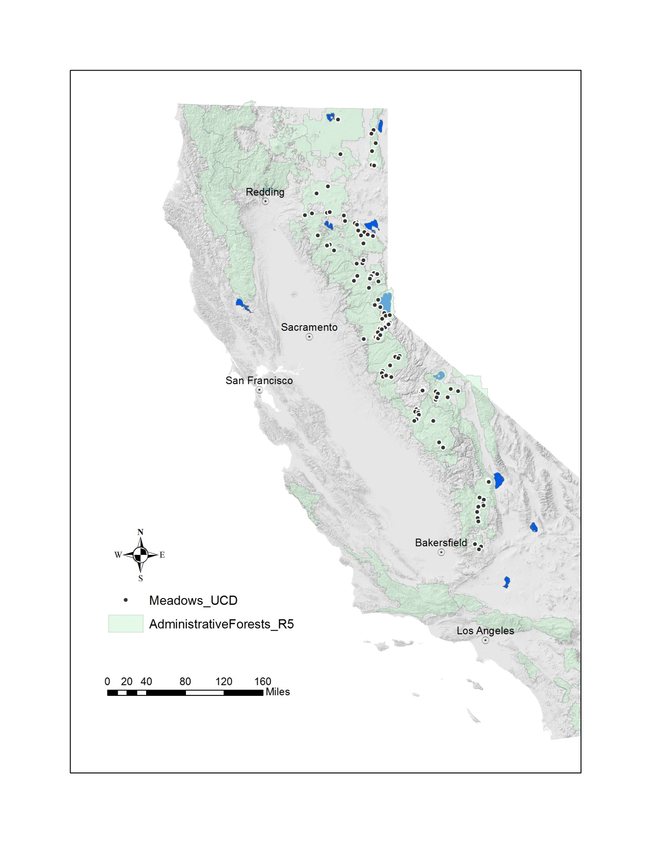

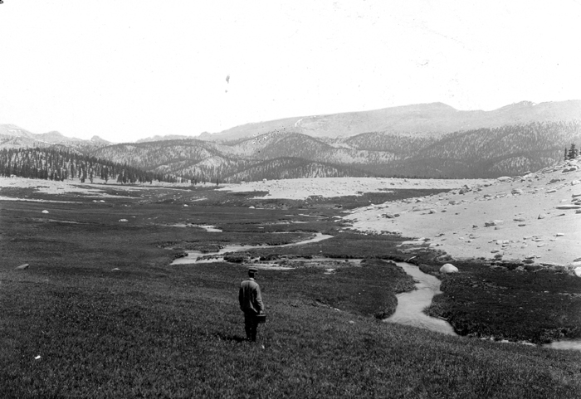
Figure 2: Photograph showing unincised Golden Trout Stream in Big Whitney Meadow (now part of Inyo National Forest), 1903 (U.S. Geological Survey photograph)
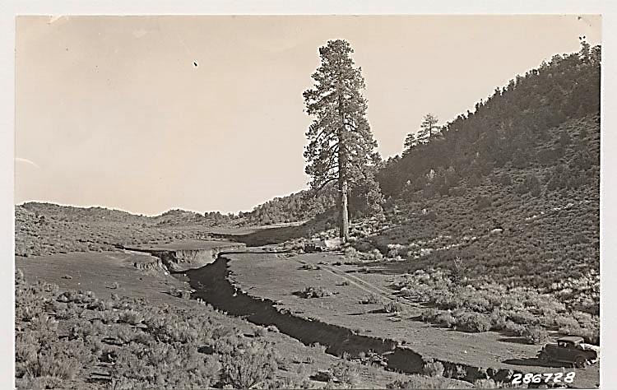
Figure 3: Photograph from the Wieslander collection (UC Berkeley) taken in 1931 showing advanced gully erosion in Big Pine Meadow in the South Fork Kern River watershed, Inyo National Forest

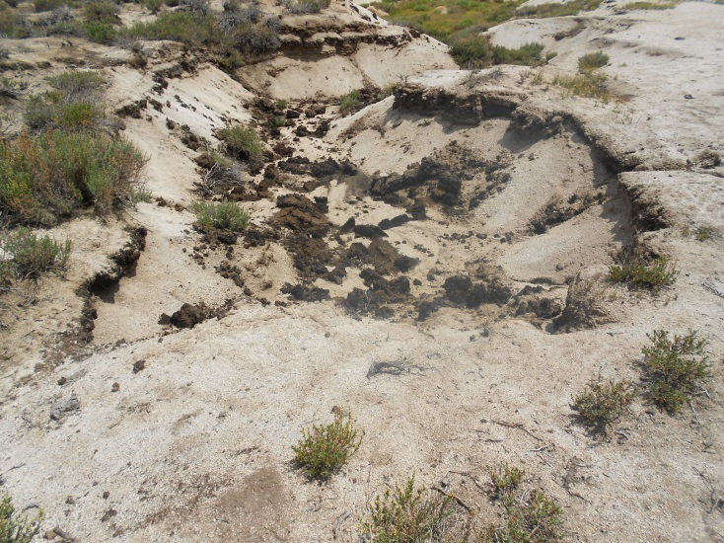

Figure 4: Headcut erosion at Diaz Meadow, Inyo National Forest, July 2014

Fig. 5: Double-mass curve, Merced River, Yosemite National Park, 1916-2011

1934
1950
Fig. 6: Double-mass curve for the South Fork Kern River near Onyx, California, 1922-2010
1934
1931
Fig. 7: Double-mass curve for Indian Creek near Crescent Mills, California,1907-56
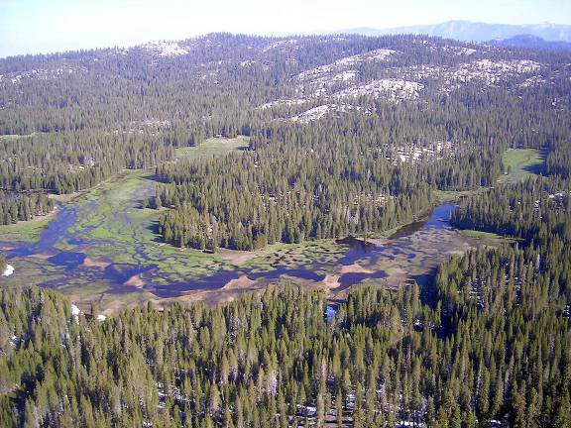
Figure 8: Overbank flooding on restored Big Meadow, Sequoia National Forest, 2011
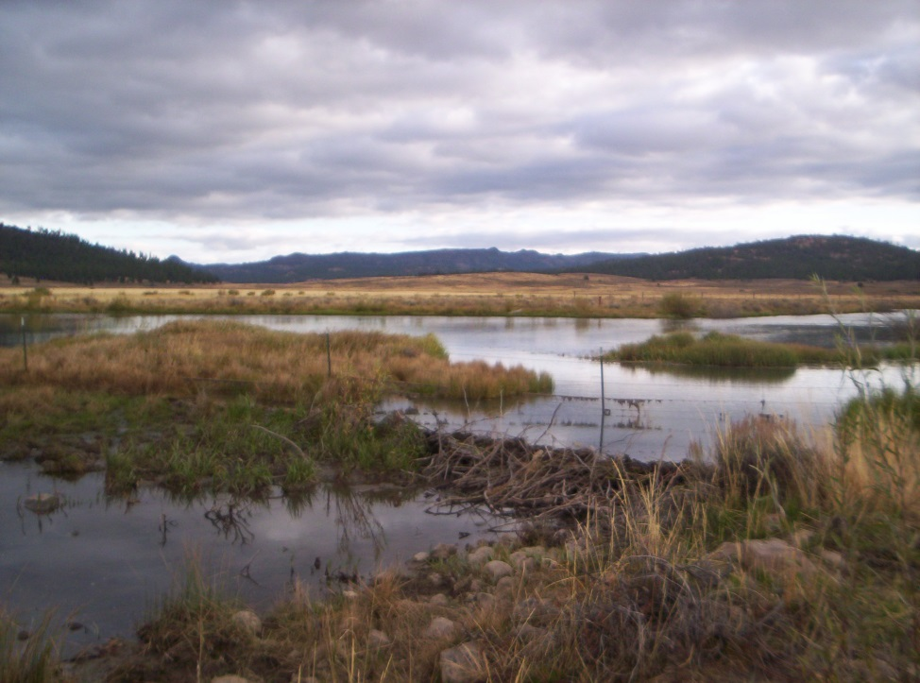
Figure 9: A constructed pond augmented by a beaver dam, Red Clover Valley, Plumas County, October 2011

Figure 10: Daily groundwater balances in cubic meters for eroded Round Meadow, July 1 to September 30, 2013

Figure 11: Daily groundwater balances in cubic meters for restored Middle Perazzo Meadow, July 1 to September 30, 2013

TABLES
Table 1: Numbers and aggregate areas of meadows on National Forests in the Sierra Nevada and Southern Cascade Range (from the Sierra Nevada Framework Planning Amendment FEIS, 2001)

National Forest | Number of meadows | Total meadow area (hectares) | Average meadow area (hectares) | Total NFS land area (hectares) | Percent of total land area in meadows
ENF | 1,797 | 4,000 | 2.2 | 276,936 | 1.40%
INF | 1,511 | 15,889 | 10.5 | 770,056 | 2.10%
LNF | 1,585 | 21,796 | 13.8 | 433,338 | 5.00%
MDF | 535 | 15,868 | 29.7 | 673,442 | 2.40%
PNF | 219 | 2,343 | 10.7 | 476,115 | 0.50%
SQF | 288 | 3,379 | 11.7 | 463,253 | 0.70%
SNF | 634 | 3,947 | 6.2 | 531,139 | 0.70%
STF | 1,854 | 5,242 | 2.8 | 363,612 | 1.40%
TNF | 667 | 9,506 | 14.3 | 352,832 | 2.70%
LTBMU | 2,523 | 7,626 | 3.0 | 77,328 | 9.90%
TOTAL | 11,613 | 89,594 |  | 4,418,050 | 2.00%

Table 2: Erosion depths measured in meadows on NFS lands in the Sierra Nevada, 2010-2012

Mean erosion depth range (m) | Number of meadows | Percentage of total | Average area (ha) | Average depth (m)
0.0 | 32 | 29 | 7.1 | 0.0
0.0 to 0.6 | 47 | 42 | 10.0 | 0.4
>0.6 | 32 | 29 | 16.7 | 1.1

Table 3: Summary of meadow hydrologic regimens from previous studies
Reference | Study Area | Meadow condition | Date of water table rise | Period with water table @ land surface | Period of overbank flow | Period of no surface flow | Annual water table drop (m)
Wood, 1975 | Yuba River, 2,225 m | Unincised | September | November-June | April-June | Mid-August to late October | 0.6 to 1.2
Hammersmark and others, 2008 | Bear Creek, 1,010 m | Restored | November-December | February-June | November-June | Mid-July to late November | 1.5 to 3.5
Loheide and Gorelick, 2007 | Alkalai Flat, Last Chance watershed, 1,680 to 2,350 m | Restored | October | April | April | None | 1.5
Loheide and Gorelick, 2007 | Big Flat, Last Chance watershed, 1,680 to 2,350 m | Restored | November-January | April | April | None | 1.5
Loheide and Gorelick, 2007 | Doyle Crossing Meadow, Last Chance watershed, 1,680 to 2,350 m | “Semi-pristine” tributary; nearby meadow incised 2 m | October- November | February-April | April | None | 1.4
Loheide and Gorelick, 2007 | Coyote Flat, Last Chance watershed, 1,680 to 2,350 m | Eroded—incised 3-5 m | February | None | None | None | 1.8
Hammersmark and others, 2008 | Bear Creek, 1,010 m | Eroded—incised 2 m | November | None (2005)  Late December (2006) | None | Mid-July to late November | 1.0 to 2.0

Table 4: Previous studies of streamflow changes following restoration of Sierra Nevada meadows
Reference | Study  area | Bedrock  geology | Average  annual  precipitation (mm) | Type of analysis | Type of  comparison | Changes to streamflow following restoration/erosion
Hammersmark and others, 2009 | Bear Creek, Lassen County | basalt | 508 | Model | Before and after restoration | Slight decrease in baseflow duration and volume within meadow, increase in baseflow volume downstream of meadow
Ohara and others, 2013 | Last Chance Creek, Plumas County | granodiorite, pyroclastic flows,underlain  by lacustrine  clay | 428 | Model | Before and after restoration | Increased baseflow volumes
Tague and others, 2008 | Trout Creek, Lake Tahoe Basin | Granodiorite and glacial deposits | 500 to 1,000 | streamflow data | Before and after restoration | Decreased winter flows, increased flows in spring and early summer
Essaid and Hill, 2014 | Sagehen Creek, Sierra County | Pyroclastic flows, glacial deposits | 850 | Model | Before and after erosion | Decreased spring flows, increased late summer flows.

Table 5: Physical characteristics of meadows monitored for summer groundwater balances, 2012

Meadow | National Forest | Condition | Bedrock geology | Watershed area (km²) | Meadow area (ha) | Average elevation (m)
M14 | Sierra | Partially eroded | Glaciated granite | 1.7 | 5.1 | 2,342
M20 | Sierra | Partially eroded | Glaciated granite | 0.5 | 1.4 | 2,662
Round | Stanislaus | Eroded | Glaciated granite | 2.6 | 2 | 1,991
Wolfin | Stanislaus | Partially eroded | Weathered granite | 0.2 | 3 | 1,554
Faust Cabin | Stanislaus | Restored | Metamorphic | 0.4 | 2 | 1,646
Trout Creek | Lake Tahoe Basin | Restored | Glaciated granite | 106 | 22 | 1,920
Middle Perazzo | Tahoe | Restored | Volcanic | 88 | 61 | 2,226
Lower Perazzo | Tahoe | Eroded | Volcanic | 94 | 15 | 2,215
Thompson | Plumas | Eroded | Volcanic | 10 | 20 | 1,676
Big Flat | Plumas | Restored | Volcanic | 39 | 9 | 1,753

Table 6: May snowpack conditions, 2011 to 2013, for the major watersheds in which meadows used for groundwater balances are located, as percentages of long-term average conditions (from California Department of Water Resources)

Meadow | National Forest | Watershed | 2011 | 2012 | 2013
M14 | Sierra | San Joaquin | 197% | 24% | 24%
M20 | Sierra | San Joaquin | 197% | 24% | 24%
Round | Stanislaus | Tuolumne | 184% | 26% | 31%
Wolfin | Stanislaus | Tuolumne | 184% | 26% | 31%
Faust Cabin | Stanislaus | Tuolumne | 184% | 26% | 31%
Trout Creek | Lake Tahoe Basin | Truckee | 220% | 71% | 8%
Middle Perazzo | Tahoe | Truckee | 220% | 71% | 8%
Lower Perazzo | Tahoe | Truckee | 220% | 71% | 8%
Thompson | Plumas | Feather | 202% | 45% | 7%
Big Flat | Plumas | Feather | 202% | 45% | 7%

Table 7: Sources of data used for meadow groundwater balances
[USGS, U.S. Geological Survey; UCM, University of California Merced; BHI, Balance Hydrologics, Inc.; DWR, California Department of Water Resources; PSW, USDA Forest Service Pacific Southwest Research Station]
Meadow | Groundwater levels | Specific yields | Streamflow | Precipitation
M14 | PSW | USGS | PSW | PSW
M20 | PSW | USGS | PSW | PSW
Round | UCM | USGS | UCM | DWR
Wolfin | UCM | USGS | UCM | DWR
Faust Cabin | UCM | USGS | UCM | DWR
Trout Creek | UCM | USGS | USGS | DWR
Middle Perazzo | BHI | USGS | BHI | DWR
Lower Perazzo | BHI | USGS | BHI | DWR
Thompson | DWR | USGS | DWR | DWR
Big Flat | UCM | USGS | UCM | DWR

Table 8: Hydrologic monitoring installations for meadow groundwater balances
Meadow | Number of piezometers | Depth range of piezometers (m below land surface) | Number of wells | Depth range of wells (m below land surface) | Streamflow monitoring stations
M14 | 13 | 0.9 to 1.4 | 0 | n/a | 1
M20 | 14 | 1.0 to 1.3 | 0 | n/a | 1
Round | 2 | 1.9 to 2.7 | 7 | 2.3 to 4.0 | 2
Wolfin | 4 | 1.8 to 2.9 | 10 | 0.8 to 3.1 | 1
Faust Cabin | 2 | 1.7 to 2.7 | 7 | 2.5 to 3.3 | 1
Trout Creek | 4 | 1.3 to 2.9 | 8 | 1.3 to 3.1 | 3
Middle Perazzo | 0 | n/a | 7 | 1.7 to 2.0 | 2
Lower Perazzo | 2 | 1.3 to 2.1 | 7 | 2.0 to 3.2 | 2
Thompson | 6 | 1.9 to 4.1 | 2 | 2.2 to 3.9 | 3
Big Flat | 2 | 2.3 to 2.7 | 6 | 2.2 to 3.2 | 2

Table 9: Specific yield results used for meadow groundwater balances, based on average meadow values
[specific yield analyses performed by USGS California Water Science Center soils laboratory in Sacramento, CA]
Meadow | Specific yield (m³/m³) at 0.3 bars of pressure
M14 | 0.2
M20 | 0.2
Round | 0.3
Wolfin | 0.2
Faust Cabin | 0.2
Trout Creek | 0.3
Middle Perazzo | 0.4
Lower Perazzo | 0.4
Thompson | 0.3
Big Flat | 0.3

Table 10: Precipitation at stations near meadows used for groundwater balances
- July 1 to September 30, 2012
Meadow | Station | Rainfall, mm
M14 | Average of Upper and Lower Bull Stations (PSW) | 41
M20 | Average of Upper and Lower Bull Stations (PSW) | 41
Round | Pinecrest DWR | 6
Wolfin | Mt. Elizabeth DWR | 2
Faust Cabin | Mt. Elizabeth DWR | 2
Trout Creek | Fallen Leaf Lake DWR | 18
Middle Perazzo | Independence Lake DWR | 2
Lower Perazzo | Independence Lake DWR | 2
Thompson | Thompson Valley DWR | 3
Big Flat | Doyle Crossing DWR | 0

- July 1 to September 30, 2013
Meadow | Station | Rainfall, mm
M14 | Tamarack DWR | 27
M20 | Tamarack DWR | 27
Round | Pinecrest DWR | 18
Wolfin | Mt. Elizabeth DWR | 13
Faust Cabin | Mt. Elizabeth DWR | 13
Trout Creek | Fallen Leaf Lake DWR | 43
Middle Perazzo | Independence Lake DWR | 3
Lower Perazzo | Independence Lake DWR | 3
Thompson | Thompson Valley DWR | 4
Big Flat | Thompson Valley DWR | 4

Table 11: Meadow groundwater balances in cubic meters per hectare
- July 1 to September 30, 2012
Meadow | Meadow storage change | Groundwater inflow from bedrock | Evapo-transpiration | Groundwater discharge to stream | Meadow condition
M14 | 1,220 | 2,980 | 4,200 | 5,992 | Partially eroded
M20 | 160 | 868 | 1,028 | 13,244 | Partially eroded
Round | 1,260 | 688 | 1,948 | 10,371 | Eroded
Wolfin | 620 | 5,128 | 5,748 | 1,317 | Partially eroded
Faust Cabin | 1,220 | 732 | 1,952 | 0 | Restored
Trout Creek | 210 | 2,480 | 2,690 | 10,149 | Restored
Middle Perazzo | 520 | 5,200 | 5,720 | 6,724 | Restored
Lower Perazzo | 1,200 | 2,256 | 3,456 | 16,531 | Eroded
Thompson | 1,500 | 488 | 1,988 | 0 | Eroded
Big Flat | 4,350 | 616 | 4,966 | 0 | Restored

- July 1 to September 30, 2013
Meadow | Meadow storage change | Groundwater inflow from bedrock | Evapo-transpiration | Groundwater discharge to stream | Meadow condition
M14 | 820 | 1,848 | 2,668 | 3,207 | Partially eroded
M20 | -120 | 704 | 584 | 3,108 | Partially eroded
Round | 3,300 | 220 | 3,520 | 3,425 | Eroded
Wolfin | 780 | 2,952 | 3,732 | 0 | Partially eroded
Faust Cabin | 1,340 | 1,000 | 2,340 | 0 | Restored
Trout Creek | 60 | 2,588 | 2,648 | 26,103 | Restored
Middle Perazzo | -120 | 6,720 | 6,600 | 7,752 | Restored
Lower Perazzo | 560 | 3,476 | 4,036 | 4,855 | Eroded
Thompson | 990 | 680 | 1,670 | 0 | Eroded
Big Flat | 4,020 | 10,480 | 14,500 | 0 | Restored

Table12: Percentage change, 2012 to 2013, in groundwater discharged from meadow aquifer to stream, July 1 to September 30
Meadow | Percent change in groundwater discharge to stream | Meadow condition
M14 | -46 | Partially eroded
M20 | -77 | Partially eroded
Round | -67 | Eroded
Wolfin | -100 | Partially eroded
Faust Cabin | 0 | Restored
Trout Creek | +157 | Restored
Middle Perazzo | +15 | Restored
Lower Perazzo | -71 | Eroded
Thompson | 0 | Eroded
Big Flat | 0 | Restored

Table 13: Maximum, minimum, and average groundwater levels in meters below land surface in meadows monitored for groundwater balances
- July 1 to September 30, 2012
Meadow | Maximum | Minimum | Average | Meadow condition
M14 | 1.09 | 0.48 | 0.83 | Partially eroded
M20 | 0.64 | 0.55 | 0.6 | Partially eroded
Round | 1.94 | 1.16 | 1.62 | Eroded
Wolfin | 1.24 | 0.70 | 1.06 | Partially eroded
Faust Cabin | 1.84 | 1.00 | 1.37 | Restored
Trout Creek | 0.72 | 0.40 | 0.67 | Restored
Middle Perazzo | 0.52 | 0.34 | 0.46 | Restored
Lower Perazzo | 1.57 | 1.01 | 1.28 | Eroded
Thompson | 1.71 | 1.22 | 1.53 | Eroded
Big Flat | 2.40 | 1.00 | 1.81 | Restored

- July 1 to September 30, 2013
Meadow | Maximum | Minimum | Average | Meadow condition
M14 | 1.23 | 0.83 | 1.10 | Partially eroded
M20 | 0.58 | 0.49 | 0.52 | Partially eroded
Round | 2.10 | 1.18 | 1.76 | Eroded
Wolfin | 1.81 | 1.14 | 1.58 | Partially eroded
Faust Cabin | 1.98 | 1.28 | 1.69 | Restored
Trout Creek | 0.83 | 0.48 | 0.69 | Restored
Middle Perazzo | 0.89 | 0.53 | 0.65 | Restored
Lower Perazzo | 1.44 | 1.17 | 1.37 | Eroded
Thompson | 1.71 | 1.38 | 1.60 | Eroded
Big Flat | 1.89 | 0.83 | 1.44 | Restored

Table 14: Vertical hydraulic gradients observated in paired wells and piezometers in water-balance meadows
[positive gradients are vertically upward]
- July 1 to September 30, 2012
Meadow | Well/Piezometer pair | Maximum gradient | Minimum gradient | Average gradient | Meadow condition
Round | P1/W2 | 0.65 | -0.27 | 0.24 | Eroded
Round | P2/W2 | 0.33 | -0.08 | 0.10 | Eroded
Round | P2/P1 | -0.01 | -0.05 | -0.03 | Eroded
Wolfin | P2/W4 | 0.07 | 0.01 | 0.03 | Partially eroded
Trout Creek | W4/P3 | 0.03 | -0.02 | 0.00 | Restored
Trout Creek | W4/P4 | 0.02 | 0.00 | 0.00 | Restored
Trout Creek | P3/P4 | 0.04 | 0.00 | 0.02 | Restored
Lower Perazzo | W1/P1 | -0.02 | -0.04 | -0.03 | Eroded
Lower Perazzo | W1/P2 | 0.24 | 0.02 | 0.14 | Eroded
Lower Perazzo | P1/P2 | 0.21 | 0.05 | 0.11 | Eroded
Thompson | TC-5/TVP6 | 0.00 | -0.08 | -0.03 | Eroded
Thompson | TV-W1/TVP2 | 0.50 | 0.03 | 0.32 | Eroded
Big Flat | P1/P2 | 0.17 | 0.01 | 0.13 | Restored

- July 1 to September 30, 2013
Meadow | Well/Piezometer pair | Maximum gradient | Minimum gradient | Average gradient | Meadow condition
Round | P1/W2 | 0.61 | -0.39 | 0.18 | Eroded
Round | P2/W2 | 0.31 | -0.11 | 0.07 | Eroded
Round | P2/P1 | 0.00 | -0.05 | -0.03 | Eroded
Wolfin | P1/W4 | -0.16 | -1.00 | -0.32 | Partially eroded
Wolfin | P2/W4 | -0.05 | -0.42 | -0.24 | Partially eroded
Wolfin | P2/P1 | 0.05 | -0.01 | 0.01 | Partially eroded
Trout Creek | W4/P4 | 0.01 | -0.02 | 0.00 | Restored
Trout Creek | P3/P4 |  |  |  | Restored
Trout Creek | W0/P2 | 0.01 | -0.04 | -0.01 | Restored
Lower Perazzo | W1/P1 | -0.03 | -0.05 | -0.04 | Eroded
Lower Perazzo | W1/P2 | 0.17 | 0.02 | 0.08 | Eroded
Lower Perazzo | P1/P2 | 0.11 | 0.07 | 0.09 | Eroded
Thompson | TC-5/TVP6 | 0.01 | -0.06 | -0.03 | Eroded
Thompson | TV-W1/TVP2 | 1.39 | 0.77 | 1.28 | Eroded
Big Flat | W2/P2 | 0.31 | 0.11 | 0.24 | Restored

Table 15: Surface inundation of water-balance meadows, October 1, 2012 to May 31, 2013
Meadow | Percent of meadow area inundated | Average number of days of inundation | Average inundation depth, m | Meadow condition
Round | 60 | 60 | 0.06 | Eroded
Wolfin | 67 | 62 | 0.05 | Partially eroded
Faust Cabin | 0 | 0 | 0 | Restored
Trout Creek | 50 | 16 | 0.04 | Restored
Middle Perazzo | 33 | 27 | 0.20 | Restored
Lower Perazzo | 75 | 9 | 0.09 | Eroded
Thompson | 25 | 37 | 0.15 | Eroded
Big Flat | 100 | 4 | 0.04 | Restored

